*#importing dataset*

data <- read.csv("heart.csv")

*#installing packages*

install.packages("GGally")

install.packages("reshape2")

install.packages("plotly")

install.packages("ggcorrplot")

#importing library

library(reshape2)

library(caret)

library(e1071)

library(randomForest)

library(naivebayes)

library(rpart)

library(class)

library(xgboost)

library(lda)

library(MASS)

library(ggplot2)

library(plotly)

library(ggcorrplot)

library(GGally)

library(dplyr)

library(tidyr)

*#data preparation*

dim(data)

str(data)

summary(data)

is.na(data)

data %>% distinct()

infinite_columns <- sapply(data, function(col) any(is.infinite(col)))

clean_data <- data[!apply(data[infinite_columns], 1, anyNA), ]

data <- clean_data

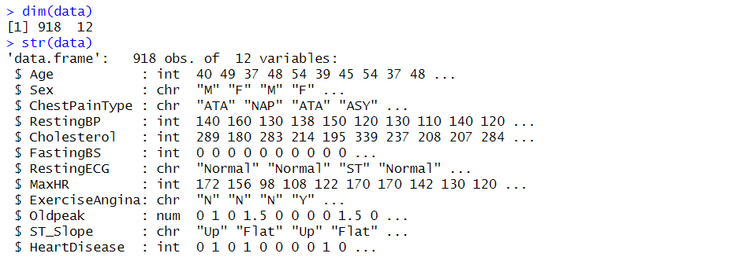

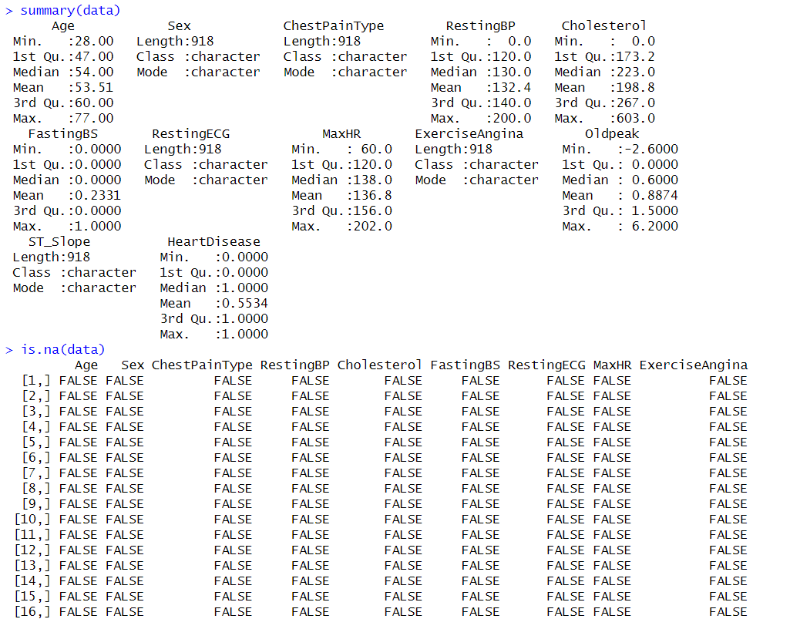

#Check for null values in each column

null_columns <- colSums(is.na(data))

print(null_columns)

*#data cleaning and transformation*

data <- na.omit(data)

data$Sex <- c(F=1 , M=0)[data$Sex]

data$ChestPainType <- c(ATA=0, NAP=1, ASY= 2)[data$ChestPainType]

data$RestingECG <- c(Normal=0, ST=1)[data$RestingECG]

data$ExerciseAngina <- c(N=0, Y=1)[data$ExerciseAngina]

data$ST_Slope <- c(Up=0, Flat=1, Down=2)[data$ST_Slope]

data$ChestPainType[is.na(data$ChestPainType)] <- median(data$ChestPainType, na.rm = TRUE)

data$Cholesterol[is.na(data$Cholesterol)] <- median(data$Cholesterol, na.rm = TRUE)

data$RestingECG[is.na(data$RestingECG)] <- median(data$RestingECG, na.rm = TRUE)

*#finding correlation*

corr_mat <- round(cor(data),2)

# reduce the size of correlation matrix

melted_corr_mat <- melt(corr_mat)

head(melted_corr_mat)

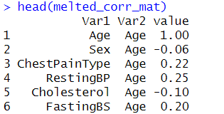

*# plotting the correlation heatmap*

ggplot(data = melted_corr_mat, aes(x=Var1, y=Var2,fill=value)) + geom_tile()

*# Select the six features from the dataset*

selected_features <- data %>%

select("Age", "Sex", "ChestPainType", "RestingBP", "Cholesterol", "MaxHR")

*# Calculate the correlation matrix for the selected features*

correlation_matrix <- cor(selected_features)

*# Create a ggplot heatmap*

heatmap_plot <- ggplot(data = as.data.frame(as.table(correlation_matrix)), aes(Var1, Var2)) +

geom_tile(aes(fill = Freq), color = "white") +

scale_fill_gradient2(low = "blue", mid = "white", high = "red", midpoint = 0, limits = c(-1, 1)) +

theme_minimal() +

theme(axis.text.x = element_text(angle = 45, hjust = 1)) +

labs(title = "Correlation Heatmap of Selected Features",

x = "Features",

y = "Features")

# Print the heatmap plot

print(heatmap_plot)

*# Create a pair plot using GGally*

ggpairs(selected_features , title = "Pair Plot of Heart Data")

*#Count plot*

ggplot(data, aes(x = HeartDisease)) + geom_bar()

*#the no of healthy and sick pepple in both gender*

result <- data %>%

group_by(Sex,HeartDisease) %>%

summarize(Count = n())

result

plot_ly(data = data, x = ~Sex, color = ~HeartDisease, type = "histogram", barmode = "group", colors = c('#71AEC2', '#D58989')) %>%

layout(title = "Distribution")

*# Pivot the data using dcast*

pivot_data <- dcast(data, Sex ~ RestingECG, value.var = "HeartDisease", fun.aggregate = mean)

*# Melt the pivoted data*

melted_data <- melt(pivot_data, id.vars = "Sex", variable.name = "RestingECG")

*# Create a pie chart for each category*

pie_chart_list <- lapply(unique(melted_data$RestingECG), function(category) {

subset_data <- melted_data[melted_data$RestingECG == category, ]

pie_chart <- ggplot(subset_data, aes(x = "", y = value, fill = Sex)) +

geom_bar(stat = "identity", width = 1) +

coord_polar("y", start = 0) +

labs(title = paste("The effect of RestingECG of both sex relations to the disease"),

x = NULL, y = NULL) +

theme_void() +

facet_wrap(~ RestingECG)

return(pie_chart)

})

print(pie_chart_list)

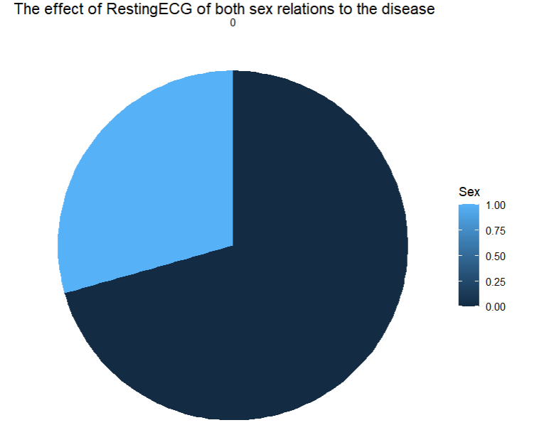

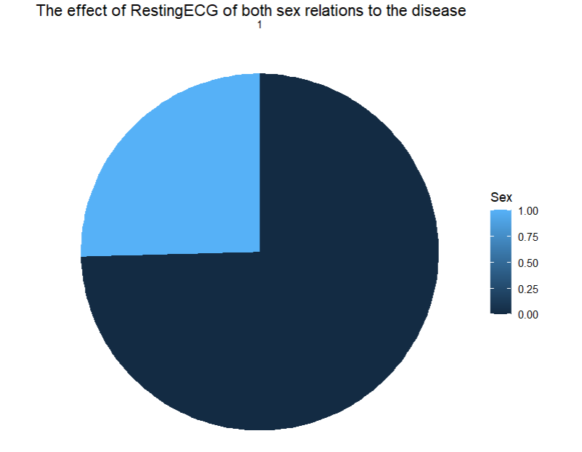

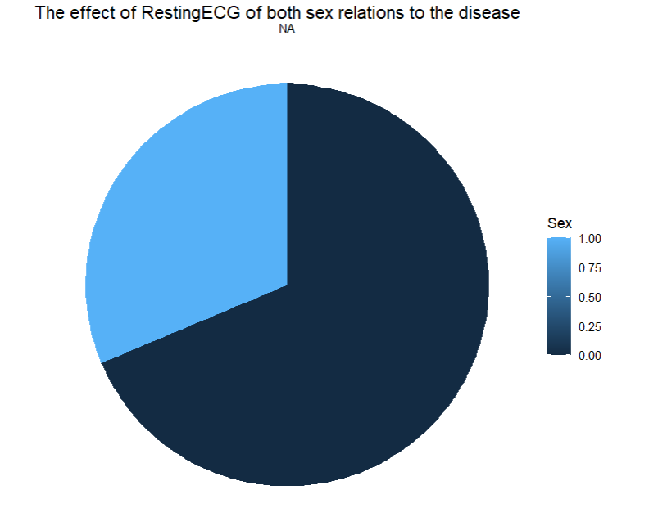

# Reshape the data

reshaped_data <- as.data.frame(pivot_data)

reshaped_data$Sex <- rownames(reshaped_data)

# Convert the data to long format

library(reshape2)

long_data <- melt(reshaped_data, id.vars = "Sex")

#checking the Distribution of maximum heart rate achieved by HeartDisease

ggplot(data, aes(x = MaxHR, fill = factor(HeartDisease))) +

geom_density(alpha = 0.5) +

scale_fill_manual(values = c("#EEDD88", "#88CCEE")) + # Set custom colors

labs(title = "Distribution of maximum heart rate achieved by HeartDisease")

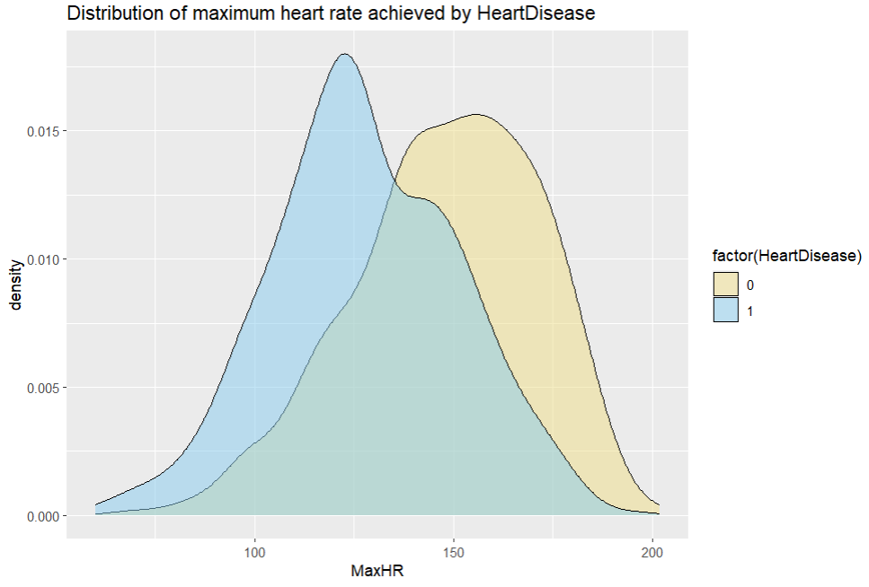

#checking Distribution of resting blood pressure by disease

ggplot(data, aes(x = as.factor(HeartDisease), y = RestingBP, color = as.factor(HeartDisease))) +

geom_jitter() +

labs(title = "Distribution of resting blood pressure by disease") +

scale_color_manual(values = c("#E41A1C", "#377EB8"))

#effect of fasting blood sugar on disease

res <- data %>%

group_by(FastingBS,HeartDisease) %>%

summarize(Count = n())

res

plot_ly(data = data, x = ~FastingBS, color = ~HeartDisease, type = "histogram", barmode = "group", colors = c('#71AEC2', '#D58989')) %>%

layout(title = "Fasting blood sugar on disease")

#the Average cholesterol for both sexes in relation to the disease

re <- aggregate(Cholesterol ~ HeartDisease + Sex, data = data, FUN = mean)

pivot_result <- reshape(re, idvar = "HeartDisease", timevar = "Sex", direction = "wide")

re

#checking the average disease for each age group

data$age_cat <- cut(data$Age, breaks = 4)

res1 <- data %>%

group_by(age_cat) %>%

summarise(mean_HeartDisease = mean(HeartDisease)) %>%

arrange(desc(mean_HeartDisease))

res1

data$HeartDisease <- factor(data$HeartDisease)

ggplot(data, aes(x = HeartDisease, fill = HeartDisease)) +

geom_bar(stat = "count") +

facet_wrap(~ age_cat, ncol = 1) +

labs(title = "Distribution of age category by disease")

#checking the average disease for each Cholesterol group

data$Chol_cat=cut(data$Cholesterol,breaks=3)

data$HeartDisease <- as.numeric(as.character(data$HeartDisease))

res2 <- data %>%

filter(is.numeric(HeartDisease)) %>%

group_by(Chol_cat) %>%

summarise(mean_HeartDisease = mean(HeartDisease, na.rm = TRUE)) %>%

arrange(desc(mean_HeartDisease))

res2

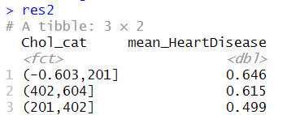

plot_ly(data, x = ~HeartDisease, color = ~HeartDisease) %>%

add_histogram(

facet_col = ~Chol_cat,

barmode = 'group',

marginal = 'rug'

) %>%

layout(

title = 'Distribution of Cholesterol categories by disease'

)

#checking the average disease for each maximum heart rate achieved group

data$MaxHR_cat=cut(data$MaxHR,breaks = 3)

res3 <- data %>%

group_by(MaxHR_cat) %>%

summarise(mean_HeartDisease = mean(HeartDisease)) %>%

arrange(desc(mean_HeartDisease))

res3

data$HeartDisease <- factor(data$HeartDisease)

ggplot(data, aes(x = HeartDisease, fill = HeartDisease)) +

geom_bar(stat = "count") +

facet_grid(. ~ MaxHR_cat) +

labs(title = "Distribution of maximum heart rate achieved by disease")

#checking What is the average disease for each Oldpeak group

data$Oldpeak_cat=cut(data$Oldpeak,breaks = 2)

data$HeartDisease <- as.numeric(as.character(data$HeartDisease))

res4 <- data %>%

group_by(Oldpeak_cat) %>%

summarise(mean_HeartDisease = mean(HeartDisease)) %>%

arrange(desc(mean_HeartDisease))

res4

plot_ly(data, x = ~HeartDisease, color = ~HeartDisease, type = "histogram") %>%

layout(barmode = "group", title = "Distribution of Heart Disease")

data <- subset(data, select = -c(age_cat, Chol_cat, MaxHR_cat, Oldpeak_cat))

#feature selection

predictor <- data[,-c(12)]

correlation <- abs(cor(predictor,data$HeartDisease,use = "everything",

method = c("pearson", "kendall", "spearman")))

correlation <- na.omit(correlation)

correlation_filter <- correlation[, 1] > 0.4

features <- names(predictor)[correlation_filter]

features



#splitting training and testing data

set.seed(123)

trainIndex <- createDataPartition(data$HeartDisease, p = 0.7, list = FALSE)

train_data <- data[trainIndex,]

test_data <- data[-trainIndex,]

log_model <- glm(HeartDisease ~ ., data=train_data,family = binomial ,model = TRUE, method = "glm.fit")

log_predictions <- predict(log_model,test_data,ype = "response")

log_predictions <- ifelse(is.na(log_predictions), 0, log_predictions)

log_predictions <- ifelse(log_predictions > 0.5, 1, 0)

plot(test_data$HeartDisease,type="l",col="red")

lines(log_predictions)

log_conf_matrix <- table(test_data$HeartDisease,log_predictions)

log_conf_matrix

#evaluating logistic regression model

log_accuracy <- sum(diag(log_conf_matrix))/sum(log_conf_matrix)

log_accuracy

log_precision <- log_conf_matrix[2,2]/(log_conf_matrix[2,1]+log_conf_matrix[2,2])

log_precision

log_recall <- log_conf_matrix[2,2]/(log_conf_matrix[2,2]+log_conf_matrix[1,2])

log_recall

log_specifi <- log_conf_matrix[1,1]/(log_conf_matrix[1,1]+log_conf_matrix[2,1])

log_specifi

log_f1_score <- 2 * ((log_precision * log_recall) / (log_precision + log_recall))

log_f1_score

#naive bayes model

nb_model <- naiveBayes(HeartDisease ~ ., data = train_data)

nb_predictions <- predict(nb_model, newdata = test_data)

plot(test_data$HeartDisease,type="l",col="red")

lines(nb_predictions)

nb_conf_matrix <- table(test_data$HeartDisease,nb_predictions)

nb_conf_matrix

#evaluating naive bayes model

nb_accuracy <- sum(diag(nb_conf_matrix))/sum(nb_conf_matrix)

nb_accuracy

nb_precision <- nb_conf_matrix[2,2]/(nb_conf_matrix[2,1]+nb_conf_matrix[2,2])

nb_precision

nb_recall <- nb_conf_matrix[2,2]/(nb_conf_matrix[2,2]+nb_conf_matrix[1,2])

nb_recall

nb_specifi <- nb_conf_matrix[1,1]/(nb_conf_matrix[1,1]+nb_conf_matrix[2,1])

nb_specifi

nb_f1_score <- 2 * ((nb_precision * nb_recall) / (nb_precision + nb_recall))

nb_f1_score

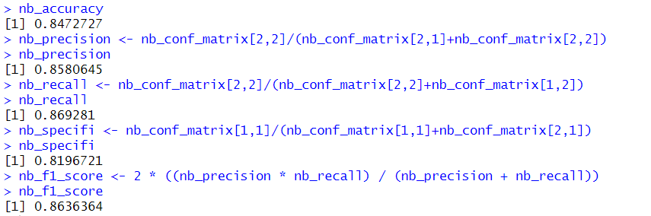

#support vector machine

svm_models <- svm(HeartDisease ~ ., data = train_data)

svm_predictions <- predict(svm_models, newdata = test_data)

svm_predictions <- ifelse(svm_predictions>0.5,1,0)

plot(test_data$HeartDisease,type="l",col="red")

lines(svm_predictions)

order_vec1 <- order(test_data$HeartDisease)

ordered_vec2 <- svm_predictions[order_vec1]

svm_conf_matrix <- table(order_vec1,ordered_vec2)

svm_conf_matrix

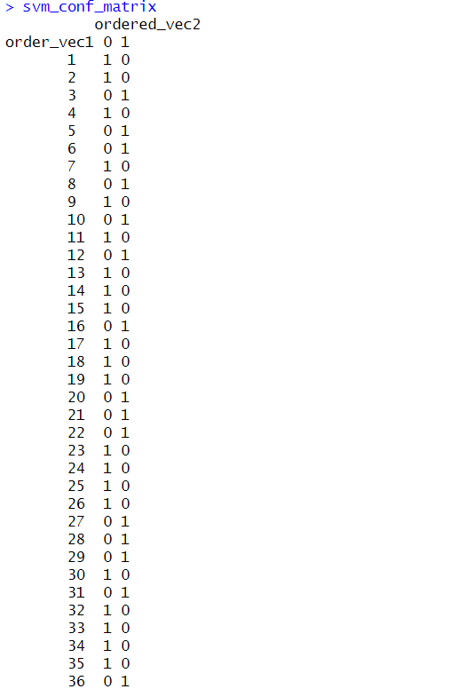

#evaluating svm model

svm_accuracy <- sum(diag(svm_conf_matrix))/sum(svm_conf_matrix)

svm_accuracy

svm_precision <- svm_conf_matrix[2,2]/(svm_conf_matrix[2,1]+svm_conf_matrix[2,2])

svm_precision

svm_recall <- svm_conf_matrix[2,2]/(svm_conf_matrix[2,2]+svm_conf_matrix[1,2])

svm_recall

svm_specifi <- svm_conf_matrix[1,1]/(svm_conf_matrix[1,1]+svm_conf_matrix[2,1])

svm_specifi

svm_f1_score <- 2 * ((svm_precision * svm_recall) / (svm_precision + svm_recall))

svm_f1_score

#decision tree

dt_model <- rpart(HeartDisease ~ ., data = train_data, method = "class")

dt_predictions <- predict(dt_model,newdata = test_data, type="class")

plot(test_data$HeartDisease,type="l",col="red")

lines(dt_predictions)

dt_conf_matrix <- table(test_data$HeartDisease,dt_predictions)

dt_conf_matrix

#evaluating decision tree model

dt_accuracy <- sum(diag(dt_conf_matrix))/sum(dt_conf_matrix)

dt_accuracy

dt_precision <- dt_conf_matrix[2,2]/(dt_conf_matrix[2,1]+dt_conf_matrix[2,2])

dt_precision

dt_recall <- dt_conf_matrix[2,2]/(dt_conf_matrix[2,2]+dt_conf_matrix[1,2])

dt_recall

dt_specifi <- dt_conf_matrix[1,1]/(dt_conf_matrix[1,1]+dt_conf_matrix[2,1])

dt_specifi

dt_f1_score <- 2 * ((dt_precision * dt_recall) / (dt_precision + dt_recall))

dt_f1_score

#random forest

rf_model <- randomForest(HeartDisease ~ .,data=train_data, na.action = na.roughfix)

rf_predictions <- predict(rf_model, newdata = test_data)

rf_predictions <- ifelse(rf_predictions>0.5,1,0)

rf_predictions

plot(test_data$HeartDisease,type="l",col="red")

lines(rf_predictions)

rf_conf_matrix <- table(test_data$HeartDisease,rf_predictions)

rf_conf_matrixdata$ChestPainType[is.na(data$ChestPainType)] <- median(data$ChestPainType, na.rm = TRUE)

data$Cholesterol[is.na(data$Cholesterol)] <- median(data$Cholesterol, na.rm = TRUE)

data$RestingECG[is.na(data$RestingECG)] <- median(data$RestingECG, na.rm = TRUE)

rf_model <- randomForest(HeartDisease ~ .,data=train_data, na.action = na.roughfix)

rf_predictions <- predict(rf_model, newdata = test_data)

rf_predictions <- ifelse(rf_predictions>0.5,1,0)

rf_predictions

plot(test_data$HeartDisease,type="l",col="red")

lines(rf_predictions)

rf_conf_matrix <- table(test_data$HeartDisease,rf_predictions)

rf_conf_matrix

#evaluating random forest

rf_accuracy <- sum(diag(rf_conf_matrix))/sum(rf_conf_matrix)

rf_accuracy

rf_precision <- rf_conf_matrix[2,2]/(rf_conf_matrix[2,1]+rf_conf_matrix[2,2])

rf_precision

rf_recall <- rf_conf_matrix[2,2]/(rf_conf_matrix[2,2]+rf_conf_matrix[1,2])

rf_recall

rf_specifi <- rf_conf_matrix[1,1]/(rf_conf_matrix[1,1]+rf_conf_matrix[2,1])

rf_specifi

rf_f1_score <- 2 * ((rf_precision * rf_recall) / (rf_precision + rf_recall))

rf_f1_score

# Linear Discriminant Analysis (LDA)

lda_model <- lda(HeartDisease ~ ., data = train_data)

lda_predictions <- predict(lda_model, newdata = test_data)$class

plot(test_data$HeartDisease,type="l",col="red")

lines(lda_predictions)

lda_conf_matrix <- table(test_data$HeartDisease,lda_predictions)

lda_conf_matrix

#evaluating lda model

lda_accuracy <- sum(diag(lda_conf_matrix))/sum(lda_conf_matrix)

lda_accuracy

lda_precision <- lda_conf_matrix[2,2]/(lda_conf_matrix[2,1]+lda_conf_matrix[2,2])

lda_precision

lda_recall <- lda_conf_matrix[2,2]/(lda_conf_matrix[2,2]+lda_conf_matrix[1,2])

lda_recall

lda_specifi <- lda_conf_matrix[1,1]/(lda_conf_matrix[1,1]+lda_conf_matrix[2,1])

lda_specifi

lda_f1_score <- 2 * ((lda_precision * lda_recall) / (lda_precision + lda_recall))

lda_f1_score

# Quadratic Discriminant Analysis (QDA)

qda_model <- qda(HeartDisease ~ ., data = train_data)

qda_predictions <- predict(qda_model, newdata = test_data)$class

plot(test_data$HeartDisease,type="l",col="red")

lines(qda_predictions)

qda_conf_matrix <- table(test_data$HeartDisease,qda_predictions)

qda_conf_matrix

#evaluating qda matrix

qda_accuracy <- sum(diag(qda_conf_matrix))/sum(qda_conf_matrix)

qda_accuracy

qda_precision <- qda_conf_matrix[2,2]/(qda_conf_matrix[2,1]+qda_conf_matrix[2,2])

qda_precision

qda_recall <- qda_conf_matrix[2,2]/(qda_conf_matrix[2,2]+qda_conf_matrix[1,2])

qda_recall

qda_specifi <- qda_conf_matrix[1,1]/(qda_conf_matrix[1,1]+qda_conf_matrix[2,1])

qda_specifi

qda_f1_score <- 2 * ((qda_precision * qda_recall) / (qda_precision + qda_recall))

qda_f1_score

#data visualization

#Accuracy

model_names <- c("logistic regression", "naive bayes", "svm", "decision tree", "random forest","knn", "lda", "qda")

accuracies <- c(log_accuracy,nb_accuracy, svm_accuracy, dt_accuracy, rf_accuracy, knn_accuracy, lda_accuracy, qda_accuracy)

accuracy_data <- data.frame(Model = model_names, Accuracy = accuracies)

ggplot(accuracy_data, aes(x = Model, y = Accuracy)) +

geom_bar(stat = "identity", fill = "skyblue") +

labs(title = "Model Accuracies", x = "Model", y = "Accuracy")

#Precision

model_names <- c("logistic regression", "naive bayes", "svm", "decision tree", "random forest","knn", "lda", "qda")

precision <- c(log_precision,nb_precision, svm_precision, dt_precision, rf_precision, knn_precision, lda_precision, qda_precision)

precision_data <- data.frame(Model = model_names, Precision = precision)

ggplot(precision_data, aes(x = Model, y = Precision)) +

geom_bar(stat = "identity", fill = "skyblue") +

labs(title = "Model precision", x = "Model", y = "precision")

#recall

model_names <- c("logistic regression", "naive bayes", "svm", "decision tree", "random forest","knn", "lda", "qda")

recall <- c(log_recall,nb_recall, svm_recall, dt_recall, rf_recall, knn_recall, lda_recall, qda_recall)

recall_data <- data.frame(Model = model_names, Recall = recall)

ggplot(recall_data, aes(x = Model, y = Recall)) +

geom_bar(stat = "identity", fill = "skyblue") +

labs(title = "Model recall", x = "Model", y = " Recall")

#specificity

model_names <- c("logistic regression", "naive bayes", "svm", "decision tree", "random forest","knn", "lda", "qda")

specificity <- c(log_specifi,nb_specifi, svm_specifi, dt_specifi, rf_specifi, knn_specifi, lda_specifi, qda_specifi)

specificity_data <- data.frame(Model = model_names, Specificity = specificity )

ggplot(specificity_data, aes(x = Model, y = Specificity )) +

geom_bar(stat = "identity", fill = "skyblue") +

labs(title = "Model specificity", x = "Model", y = "specificity")

#f1 score

model_names <- c("logistic regression", "naive bayes", "svm", "decision tree", "random forest","knn", "lda", "qda")

f1_score <- c(log_f1_score,nb_f1_score, svm_f1_score, dt_f1_score, rf_f1_score, knn_f1_score, lda_f1_score, qda_f1_score)

f1_score_data <- data.frame(Model = model_names, F1_score = f1_score )

ggplot(f1_score_data, aes(x = Model, y = f1_score )) +

geom_bar(stat = "identity", fill = "skyblue") +

labs(title = "Model f1_score", x = "Model", y = "f1_score")

#features

train_data_features <- subset(train_data, select = c( "ChestPainType", "MaxHR", "ExerciseAngina", "Oldpeak", "ST_Slope","HeartDisease"))

test_data_features <- subset(test_data,select = c("ChestPainType", "MaxHR", "ExerciseAngina", "Oldpeak", "ST_Slope","HeartDisease"))

#logistic regression model with selected features

log_model_f <- glm(HeartDisease ~ ., data = train_data_features,family = binomial ,model = TRUE, method = "glm.fit")

log_predictions_f <- predict(log_model_f,test_data_features,type = "response")

log_predictions_f <- ifelse(is.na(log_predictions_f), 0, log_predictions_f)

log_predictions_f <- ifelse(log_predictions_f > 0.5, 1, 0)

log_conf_matrix_f <- table(test_data_features$HeartDisease,log_predictions_f)

log_conf_matrix_f

#evaluating logistic regression model

log_accuracy_f <- sum(diag(log_conf_matrix_f))/sum(log_conf_matrix_f)

log_accuracy_f

log_precision_f <- log_conf_matrix_f[2,2]/(log_conf_matrix_f[2,1]+log_conf_matrix_f[2,2])

log_precision_f

log_recall_f <- log_conf_matrix_f[2,2]/(log_conf_matrix_f[2,2]+log_conf_matrix_f[1,2])

log_recall_f

log_specifi_f <- log_conf_matrix_f[1,1]/(log_conf_matrix_f[1,1]+log_conf_matrix_f[2,1])

log_specifi_f

log_f1_score_f <- 2 * ((log_precision_f * log_recall_f) / (log_precision_f + log_recall_f))

log_f1_score_f

#naive bayes model features

nb_model_f <- naiveBayes(HeartDisease ~ ., data = train_data_features)

nb_predictions_f <- predict(nb_model_f, newdata = test_data_features)

nb_conf_matrix_f <- table(test_data_features$HeartDisease,nb_predictions_f)

nb_conf_matrix_f

#evaluating naive bayes model

nb_accuracy_f <- sum(diag(nb_conf_matrix_f))/sum(nb_conf_matrix_f)

nb_accuracy_f

nb_precision_f <- nb_conf_matrix_f[2,2]/(nb_conf_matrix_f[2,1]+nb_conf_matrix_f[2,2])

nb_precision_f

nb_recall_f <- nb_conf_matrix_f[2,2]/(nb_conf_matrix_f[2,2]+nb_conf_matrix_f[1,2])

nb_recall_f

nb_specifi_f <- nb_conf_matrix_f[1,1]/(nb_conf_matrix_f[1,1]+nb_conf_matrix_f[2,1])

nb_specifi_f

nb_f1_score_f <- 2 * ((nb_precision_f * nb_recall_f) / (nb_precision_f + nb_recall_f))

nb_f1_score_f

#support vector machine with features

svm_models_f <- svm(HeartDisease ~ ., data = train_data_features)

svm_predictions_f <- predict(svm_models_f, newdata = test_data_features)

svm_predictions_f <- ifelse(svm_predictions_f>0.5,1,0)

svm_conf_matrix_f <- table(test_data_features$HeartDisease,svm_predictions_f)

svm_conf_matrix_f

#evaluating svm model

svm_accuracy_f <- sum(diag(svm_conf_matrix_f))/sum(svm_conf_matrix_f)

svm_accuracy_f

svm_precision_f <- svm_conf_matrix_f[2,2]/(svm_conf_matrix_f[2,1]+svm_conf_matrix_f[2,2])

svm_precision_f

svm_recall_f <- svm_conf_matrix_f[2,2]/(svm_conf_matrix_f[2,2]+svm_conf_matrix_f[1,2])

svm_recall_f

svm_specifi_f <- svm_conf_matrix_f[1,1]/(svm_conf_matrix_f[1,1]+svm_conf_matrix_f[2,1])

svm_specifi_f

svm_f1_score_f <- 2 * ((svm_precision_f * svm_recall_f) / (svm_precision_f + svm_recall_f))

svm_f1_score_f

#decision tree

dt_model_f <- rpart(HeartDisease ~ ., data = train_data_features, method = "class")

dt_predictions_f <- predict(dt_model_f,newdata = test_data_features, type="class")

dt_predictions_f

dt_conf_matrix_f <- table(test_data_features$HeartDisease,dt_predictions_f)

dt_conf_matrix_f

#evaluating decision tree model

dt_accuracy_f <- sum(diag(dt_conf_matrix_f))/sum(dt_conf_matrix_f)

dt_accuracy_f

dt_precision_f <- dt_conf_matrix_f[2,2]/(dt_conf_matrix_f[2,1]+dt_conf_matrix_f[2,2])

dt_precision_f

dt_recall_f <- dt_conf_matrix_f[2,2]/(dt_conf_matrix_f[2,2]+dt_conf_matrix_f[1,2])

dt_recall_f

dt_specifi_f <- dt_conf_matrix_f[1,1]/(dt_conf_matrix_f[1,1]+dt_conf_matrix_f[2,1])

dt_specifi_f

dt_f1_score_f <- 2 * ((dt_precision_f * dt_recall_f) / (dt_precision_f + dt_recall_f))

dt_f1_score_f

#random forest with features

rf_model_f <- randomForest(HeartDisease ~ .,data=train_data_features)

rf_predictions_f <- predict(rf_model_f, newdata = test_data_features)

rf_predictions_f <- ifelse(rf_predictions_f>0.5,1,0)

rf_conf_matrix_f <- table(test_data_features$HeartDisease,rf_predictions_f)

rf_conf_matrix_f

#evaluating random forest

rf_accuracy_f <- sum(diag(rf_conf_matrix_f))/sum(rf_conf_matrix_f)

rf_accuracy_f

rf_precision_f <- rf_conf_matrix_f[2,2]/(rf_conf_matrix_f[2,1]+rf_conf_matrix_f[2,2])

rf_precision_f

rf_recall_f <- rf_conf_matrix_f[2,2]/(rf_conf_matrix_f[2,2]+rf_conf_matrix_f[1,2])

rf_recall_f

rf_specifi_f <- rf_conf_matrix_f[1,1]/(rf_conf_matrix_f[1,1]+rf_conf_matrix_f[2,1])

rf_specifi_f

rf_f1_score_f <- 2 * ((rf_precision_f * rf_recall_f) / (rf_precision_f + rf_recall_f))

rf_f1_score_f

#knn

knn_model_f <- knn(train_data_features[, -1], test_data_features[, -1], train_data_features$HeartDisease, k = 2)

knn_predictions_f <- as.numeric(knn_model_f)

knn_predictions_f <- ifelse(knn_predictions_f==2,1,0)

knn_predictions_f

knn_conf_matrix_f <- table(test_data_features$HeartDisease,knn_predictions_f)

knn_conf_matrix_f

#evaluating knn model

knn_accuracy_f <- sum(diag(knn_conf_matrix_f))/sum(knn_conf_matrix_f)

knn_accuracy_f

knn_precision_f <- knn_conf_matrix_f[2,2]/(knn_conf_matrix_f[2,1]+knn_conf_matrix_f[2,2])

knn_precision_f

knn_recall_f <- knn_conf_matrix_f[2,2]/(knn_conf_matrix_f[2,2]+knn_conf_matrix_f[1,2])

knn_recall_f

knn_specifi_f <- knn_conf_matrix_f[1,1]/(knn_conf_matrix_f[1,1]+knn_conf_matrix_f[2,1])

knn_specifi_f

knn_f1_score_f <- 2 * ((knn_precision_f * knn_recall_f) / (knn_precision_f + knn_recall_f))

knn_f1_score_f

# Linear Discriminant Analysis (LDA) with selected features

lda_model_f <- lda(HeartDisease ~ ., data = train_data_features)

lda_predictions_f <- predict(lda_model_f, newdata = test_data_features)$class

lda_conf_matrix_f <- table(test_data_features$HeartDisease,lda_predictions_f)

lda_conf_matrix_f

#evaluating lda model

lda_accuracy_f <- sum(diag(lda_conf_matrix_f))/sum(lda_conf_matrix_f)

lda_accuracy_f

lda_precision_f <- lda_conf_matrix_f[2,2]/(lda_conf_matrix_f[2,1]+lda_conf_matrix_f[2,2])

lda_precision_f

lda_recall_f <- lda_conf_matrix_f[2,2]/(lda_conf_matrix_f[2,2]+lda_conf_matrix_f[1,2])

lda_recall_f

lda_specifi_f <- lda_conf_matrix_f[1,1]/(lda_conf_matrix_f[1,1]+lda_conf_matrix_f[2,1])

lda_specifi_f

lda_f1_score_f <- 2 * ((lda_precision_f * lda_recall_f) / (lda_precision_f + lda_recall_f))

lda_f1_score_f

# Quadratic Discriminant Analysis (QDA)

qda_model_f <- qda(HeartDisease ~ ., data = train_data_features)

qda_predictions_f <- predict(qda_model_f, newdata = test_data_features)$class

qda_conf_matrixS_f <- table(test_data_features$HeartDisease,qda_predictions_f)

qda_conf_matrix_f

#data visualization

#Accuracy

model_names_f <- c("logistic regression", "naive bayes", "svm", "decision tree", "random forest","knn", "lda", "qda")

accuracies_f <- c(log_accuracy_f,nb_accuracy_f, svm_accuracy_f, dt_accuracy_f, rf_accuracy_f, knn_accuracy_f, lda_accuracy_f, qda_accuracy_f)

accuracy_data_f <- data.frame(Model_f = model_names_f, Accuracy_f = accuracies_f)

ggplot(accuracy_data_f, aes(x = Model_f, y = Accuracy_f)) +

geom_bar(stat = "identity", fill = "skyblue") +

labs(title = "Model Accuracies", x = "Model", y = "Accuracy")

#Precision

precision_f <- c(log_precision_f,nb_precision_f, svm_precision_f, dt_precision_f, rf_precision_f, knn_precision_f, lda_precision_f, qda_precision_f)

precision_data_f <- data.frame(Model = model_names_f, Precision = precision_f)

ggplot(precision_data_f, aes(x = Model, y = Precision)) +

geom_bar(stat = "identity", fill = "skyblue") +

labs(title = "Model precision", x = "Model", y = "precision")

#recall

recall_f <- c(log_recall_f,nb_recall_f, svm_recall_f, dt_recall_f, rf_recall_f, knn_recall_f, lda_recall_f, qda_recall_f)

recall_data_f <- data.frame(Model = model_names_f, Recall = recall_f)

ggplot(recall_data, aes(x = Model, y = Recall)) +

geom_bar(stat = "identity", fill = "skyblue") +

labs(title = "Model recall", x = "Model", y = " Recall")

#specificity

specificity_f <- c(log_specifi_f,nb_specifi_f, svm_specifi_f, dt_specifi_f, rf_specifi_f, knn_specifi_f, lda_specifi_f, qda_specifi_f)

specificity_data_f <- data.frame(Model = model_names_f, Specificity = specificity_f )

ggplot(specificity_data_f, aes(x = Model, y = specificity )) +

geom_bar(stat = "identity", fill = "skyblue") +

labs(title = "Model specificity", x = "Model", y = "specificity")

#f1 score

f1_score_f <- c(log_f1_score_f,nb_f1_score_f, svm_f1_score_f, dt_f1_score_f, rf_f1_score_f, knn_f1_score_f, lda_f1_score_f, qda_f1_score_f)

f1_score_data_f <- data.frame(Model = model_names_f, F1_score = f1_score_f )

ggplot(f1_score_data_f, aes(x = Model, y = F1_score )) +

geom_bar(stat = "identity", fill = "skyblue") +

labs(title = "Model f1_score", x = "Model", y = "f1_score")

#evaluating models

log_eval <- sum(log_accuracy,log_precision,log_recall,log_specifi,log_f1_score)

log_eval_f <- sum(log_accuracy_f,log_precision_f,log_recall_f,log_specifi_f,log_f1_score_f)

nb_eval <- sum(nb_accuracy,nb_precision,nb_specifi,nb_recall,nb_f1_score)

nb_eval_f <- sum(nb_accuracy_f,nb_precision_f,nb_specifi_f,nb_recall_f,nb_f1_score_f)

svm_eval <- sum(svm_accuracy,svm_precision,svm_specifi,svm_recall,svm_f1_score)

svm_eval_f <- sum(svm_accuracy_f,svm_precision_f,svm_specifi_f,svm_recall_f,svm_f1_score_f)

dt_eval <- sum(dt_accuracy,dt_precision,dt_specifi,dt_recall,dt_f1_score)

dt_eval_f <- sum(dt_accuracy_f,dt_precision_f,dt_specifi_f,dt_recall_f,dt_f1_score_f)

rf_eval <- sum(rf_accuracy,rf_precision,rf_specifi,rf_recall,rf_f1_score)

rf_eval_f <- sum(rf_accuracy_f,rf_precision_f,rf_specifi_f,rf_recall_f,rf_f1_score_f)

knn_eval <- sum(knn_accuracy,knn_precision,knn_specifi,knn_recall,knn_f1_score)

knn_eval_f <- sum(knn_accuracy_f,knn_precision_f,knn_specifi_f,knn_recall_f,knn_f1_score_f)

lda_eval <- sum(lda_accuracy,lda_precision,lda_specifi,lda_recall,lda_f1_score)

lda_eval_f <- sum(lda_accuracy_f,lda_precision_f,lda_specifi_f,lda_recall_f,lda_f1_score_f)

qda_eval <- sum(qda_accuracy,qda_precision,qda_specifi,qda_recall,qda_f1_score)

qda_eval_f <- sum(qda_accuracy_f,qda_precision_f,qda_specifi_f,qda_recall_f,qda_f1_score_f)

#visualizing

model_names <- c("logistic regression", "naive bayes", "svm", "decision tree", "random forest","knn", "lda", "qda")

visualizing <- c(log_eval,nb_eval, svm_eval, dt_eval, rf_eval, knn_eval, lda_eval, qda_eval)

visual_data <- data.frame(Model = model_names, Eval = visualizing)

ggplot(visual_data, aes(x = Model, y = Eval)) +

geom_bar(stat = "identity", fill = "pink") +

labs(title = "Model evaluation", x = "Model", y = "Evaluation")

model_names_f <- c("logistic regression", "naive bayes", "svm", "decision tree", "random forest","knn", "lda", "qda")

visualizing_f <- c(log_eval_f,nb_eval_f, svm_eval_f, dt_eval_f, rf_eval_f, knn_eval_f, lda_eval_f, qda_eval_f)

visual_data_f <- data.frame(Model = model_names_f, Eval = visualizing_f)

ggplot(visual_data_f, aes(x = Model, y = Eval)) +

geom_bar(stat = "identity", fill = "pink") +

labs(title = "Model evaluation with selected features", x = "Model", y = "Evaluation")

CONCLUSION:

knn model works really well with selected features : FastingBS, RestingECG, MaxHR, ExerciseAngina

linear discriminant analysis works well with all the features